FOR IMMEDIATE RELEASE: March 22, 2019
CONTACT: Lois Durso, 239-825-2497, stopunderrides@gmail.com
Marianne Karth, 432-556-1567, marianne@annaleahmary.com

MEDIA ALERT
Truck Underride Crash Tests Coming to DC

2 Moms, who lost daughters due to truck underride, organizing public crash testing of cars into truck trailers – with and without lifesaving underride guards –
to demonstrate need for passage of federal STOP Underrides! legislation

Because No One Needs to Die Like This!
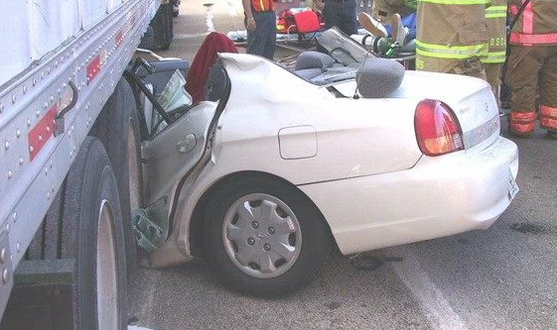

WHEN: March 26, 2019 at 10:00 a.m.

WHAT: Relatives of truck underride crash victims will hold a public crash testing of cars into tractor-trailers — with and without lifesaving underride prevention technology. The underride crash victims’ families hail from North Carolina, Florida, Texas, Colorado, New York, South Carolina and Louisville KY metro area.

They will be joined by members of Congress and vehicle safety engineering experts.

Two side impact guard systems will be tested: AngelWing and SafetySkirt. The crash tests will provide a rare opportunity to witness firsthand the importance of the bipartisan / bicameral STOP Underrides! legislation, S.665 & HR 1511, that was introduced in Congress earlier this month.

WHERE: Buzzard Point Parking Lot #147, Adjacent to the United Soccer/Audi Field
1880 2nd Street, SW, Washington, DC
https://www.google.ca/maps/@38.8710059,-77.0086588,14.53z

WHO:
Marianne Karth of Raleigh, NC. On May 4, 2013, a truck collided with her family car on I-20 in Georgia, forcing their vehicle to spin around and crash under a truck trailer in front of them. Her daughters AnnaLeah (17) and Mary (13) were in the back seat. AnnaLeah died instantly and Mary a few days later. Marianne’s husband Jerry and daughter Susanna will accompany her at this crash test demonstration.

Lois Durso of Marco Island, Florida. On Thanksgiving Day November 24, 2004, her daughter Roya and fiancé were involved in a truck underride crash in Michigan City, Indiana causing fatal injuries to her daughter.

Congresswoman Eleanor Holmes Norton (D-DC), Chair of the Highways and Transit Subcommittee, which has jurisdiction over the STOP Underrides! bill.

Underride Q&A Panelists:
- David Friedman, Vice President for Advocacy at Consumer Reports, former CR Director of Cars and Product Policy and Analysis, former Acting Administrator of National Highway Traffic Safety Administration (NHTSA).
- Malcolm Deighton, engineer with Hydro, which supplies materials for manufacturing underride protective devices and trailer parts, and which produces comprehensive underride protection technology in Europe.
- Glen Berry, Safety Director for Thomas Transport Delivery and truck driver with an AngelWing installed underride guard since 2017.
- Perry Ponder, inventor of AngelWing, engineer with a truck trailer maker.

Other victim families available for interviews:

Christa Hammack lost her daughter, Erin Alexander, in a side underride crash on May 4, 2018, in Texas. Christa lives in southern Indiana near Louisville, KY.

Katie Strader of Loveland, CO, lost her dad, Rod Cota, an ambulance worker, in a side underride crash on July 6, 2017, in New York (which caught bill sponsor Senator Gillibrand's attention).

Eric Hein whose son Riley Hein died in a side underride crash in New Mexico.

VIDEO FOOTAGE
Link to YouTube with previous underride crash testing video, photos of crashes and victims, and soundbites of relatives of crash victims, for your free and unrestricted use: https://www.youtube.com/watch?v=UR9nhxGxs64&feature=youtu.be

MORE ON “STOP Underrides! Legislation (S.665 and HR 1511), a bill to reduce the number of preventable deaths and injuries caused by underride crashes.

S.665 was introduced by Sen. Kirsten Gillibrand (NY) and is cosponsored by Senators Marco Rubio (FL), Richard Blumenthal (CT), Ed Markey (MA), Tammy Duckworth (IL), Gary Peters (MI), Dianne Feinstein (CA), Ron Wyden (OR), Tom Udall (NM), and Cory Booker (NJ). The bill was referred to the Senate Commerce, Science and Transportation Committee.

HR 1511 was introduced by Rep. Steve Cohen (TN) and referred to the House Transportation and Infrastructure Subcommittee on Highways and Transit, chaired by Rep. Eleanor Holmes Norton (DC).

PETITION DRIVE
Americans can help end this many decades-old problem that’s claimed countless lives by signing this petition: Congress, Act Now To End Deadly Truck Underride!

WEBSITES
Karth Family’s truck safety website in memory of daughters AnnaLeah & Mary:
http://annaleahmary.com/

Lois Dorso’s Save Lives-Stop Underrides website in memory of daughter Roya:
https://stopunderrides.org/

TWITTER
@MaryandAnnaLeah
@durso_lois

FACEBOOK
@MaryandAnnaLeah

####

